INDIAN SCHOOL AL SEEB
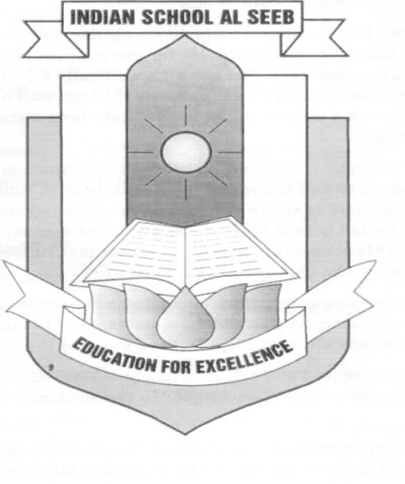

CERTIFICATE
It is hereby certified that Miss Rishika Singh of class XII has carried out the necessary project work in Informatics Practices as per the syllabus prescribed by the Central Board of Secondary Education, New Delhi, for the year 2019 - 2020.

Registration No. ___________

Internal Examiner External Examiner

Date:

School Seal: Leena Francis
PRINCIPAL

